Alg 4 Name: ____________________________

______________ _____________

WS Assessment

Target 21:

Periodic function

**I can:**

* Interpret, model and graph periodic phenomena with trigonometric function.
* Identify the properties of Sine and Cosine function

**Unit 8: Trigonometry Function**

* [**HSF.TF.A.2**](http://www.corestandards.org/Math/Content/HSF/TF/A/2/): Explain how the unit circle in the coordinate plane enables the extension of trigonometric functions to all real numbers, interpreted as radian measures of angles traversed counterclockwise around the unit circle.
* [**HSF.TF.B.5**](http://www.corestandards.org/Math/Content/HSF/TF/B/5/): Choose trigonometric functions to model periodic phenomena with specified amplitude, frequency, and midline.*
* [**HSF.IF.C.7.E**](http://www.corestandards.org/Math/Content/HSF/IF/C/7/e/): Graph ~~exponential and logarithmic functions, showing intercepts and end behavior, and~~ trigonometric functions, showing period, midline, and amplitude.

HW# 21 Periodic Function [www.deltamath.com](http://www.deltamath.com)

Periodic Function: Sine and Cosine

A periodic function occurs when a specific horizontal shift, P, results in the original function;

where *f* (x + P) = *f* (x) for all values of x. When this occurs, we call the horizontal shift P the period of the function. (In other words, things are repeated after a period of time).

Example of periodic function (5 of them)?

The graph of periodic function over the time is called sinusoidal graph

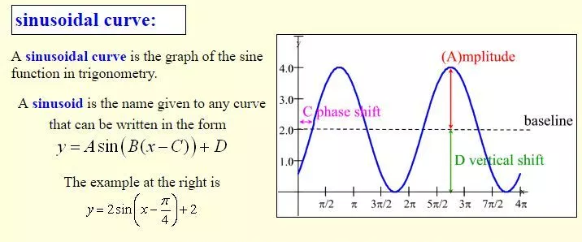

Period and Frequency

The **period** P of a function is the horizontal length of one complete cycle.

The **frequency** B of a trigonometric function is the number of cycles it completes in a given interval. This interval is generally 2π radians (or 360º) for the sine and cosine curves

Formula: $B=\frac{2π}{P}$ $P=\frac{2π}{B}$

Find the amplitude A, period P, frequency B, phase shift C, Vertical Shift D and baseline (midline) of the following functions

|  |  |
| --- | --- |
|  |  |
|  |  |

Analyzing the graph of the sine function. Suppose you have the graph of y = sin x.

Sketch it in the interval −2π ≤ x ≤ 2π?

What are the x-intercepts, when we look at the interval −2π ≤ x ≤ 2π?

What is the y-intercept?

For what numbers x, −π ≤ x ≤ π, is the graph increasing?

What is the maximum value of y = sin x?

Analyzing the graph of the cosine function. Suppose you have the graph of y = cos x.

Sketch it in the interval −2π ≤ x ≤ 2π?

What are the x-intercepts, when we look at the interval −2π ≤ x ≤ 2π?

What is the y-intercept?

For what numbers x, −π ≤ x ≤ π, is the graph increasing?

What is the minimum value of y = cos x?

Sine and Cosine function

*y =* ***a******sin*** *(****b*** *(x – c)) + d y =* ***a******cos*** *(****b*** *(x – c)) + d*

*amplitude = |a| period p= $\frac{2π}{|b|}$ frequency b = $\frac{2π}{p}$ phase shift = c vertical shift = d*

*remember cos x = sin (x + π/2) → shift left π/2 radian*

*sin x = cos (x – π/2) → shift right π/2 radian*

Find all characteristic of the following function without graphing it

|  |  |  |  |  |
| --- | --- | --- | --- | --- |
| Function | y = 2 sin x | y = −4 cos(2x) | y = $\frac{5}{3}sin⁡(\frac{-2π}{3}x+1)$ | y = 3 $sin⁡\frac{-2}{3}(x+1)$ +2 |
| Amplitude |  |  |  |  |
| Frequency |  |  |  |  |
| Period |  |  |  |  |
| Phaseshift |  |  |  |  |
| Vert. shift |  |  |  |  |

Given the characteristic find the function

|  |  |  |  |  |
| --- | --- | --- | --- | --- |
| Amplitude | 2 | 2 | 3 | 3 |
| Frequency | 3 |  | 2 $π$ |  |
| Period |  | 3 |  | 2 $π$ |
| Phaseshift | 2 | -2 | $$π/2$$ | 3/ $π$ |
| Vert. shift | 3 | -3 | 3/ $π$ | $$π/2$$ |
| Function |  |  |  |  |

Rewrite the function $f\left(x\right)=\sin\left(2x-\frac{π}{2}\right)+2$ to its correct format. Then rewrite again as a cosine function. Show me all three for stamp.

Rewrite the function $f\left(x\right)=\cos\left(3x-\frac{π}{3}\right)+3$ to its correct format. Then rewrite again as a sine function. Show me all three for stamp.

The temperature in Sam’s home varies sinusoidal over time. Given the equation

T = 4 cos( 30(t − 8))° +16 describes the temperature of the house in degrees Celsius in terms of the number of hours since 12 midnight.

Create a *table* and a *graph* that describes the temperature in Sam’s house, in terms of time, in hours since 12 midnight.

|  |  |  |  |  |  |  |  |  |  |  |  |  |  |
| --- | --- | --- | --- | --- | --- | --- | --- | --- | --- | --- | --- | --- | --- |
| time | 0 | 1 | 2 | 3 | 4 | 5 | 6 | 7 | 8 | 9 | 10 | 11 | 12 |
| Temperature | **14** |  |  |  |  |  |  |  |  |  |  |  |  |
| time | 13 | 14 | 15 | 16 | 17 | 18 | 19 | 20 | 21 | 22 | 23 | 24 | 25 |
| Temperature |  |  |  |  |  |  |  |  |  |  |  |  |  |

Determine the length of time the temperature is below 14 oC

What is the temperature in the house when Sam gets home at 4:15?

Assessment Target 20

**I can…** interpret, model and graph periodic phenomena with trigonometric function.

Find the amplitude, frequency, period, and phase shift, vertical shift of each function then **graph**

Show at least ONE cycle. Hint: Do you rewrite it in correct format yet?

y = 3 sin(3x − π) y = $-3\cos\left(\frac{1}{3}x+\frac{π}{3}\right)+3$

Write the equation of a sine function that has the given characteristics:

Amplitude =2 Period = 3 Phase shift = 2 Vertical shift = 3

Amplitude = 3 Period: 2π Phase shift = - π/2 Vertical shift = - π/3

Rewrite the function $f\left(x\right)=\sin\left(3x-\frac{π}{4}\right)+2$ to its correct format. Then rewrite again as a cosine function. Show me all three for stamp.

Rewrite the function $f\left(x\right)=\cos\left(4x-\frac{π}{3}\right)-2$ to its correct format. Then rewrite again as a sine function. Show me all three for stamp.

A waterwheel of radius 3 m is submerged such that its bottom is 2 m under water.

At t = 0, it lifts up a boot (submerged to a depth of 2m) that gets stuck in a spoke.

Five seconds later the boot is at a high point.

Create a table and a graph that describes the height of the boot above water level, in metres, in terms of time, in seconds since the boot was caught in a spoke.

|  |  |  |  |  |  |  |  |  |
| --- | --- | --- | --- | --- | --- | --- | --- | --- |
| Time | 0 | 2.5 | 5 | 7.5 | 10 | 12.5 | 15 | 17.5 |
| Height | -2 |  | 4 |  |  |  |  |  |

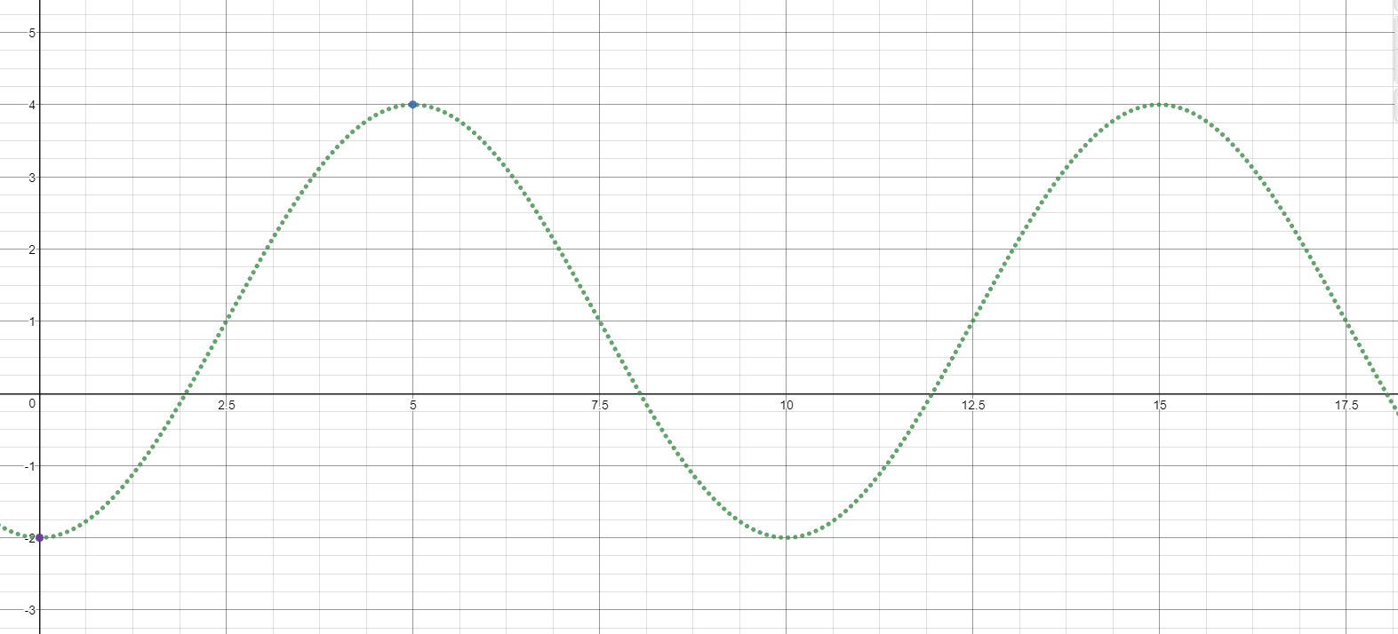

Stamp

Find all possible times when the boot will be 2 m above the water.

Determine the length of time the boot is above water level.

Is the boot in the water or above the water at 22 seconds?